Business Constraints/Regulations:

What constraints or regulations exist that might limit your farm business production or goals? What do these constraints mean for your farm business, and how will you deal with them?

You may want to consider some or all of the following:
- Legal structure of your business, both now and in the future.
- Employer responsibilities and employee rights
- Government requirements: e.g. employment insurance, farm business registration (FBR) number, premises identification number
- Tax situation: e.g. to reduce farm property tax, aiming for $7,000 to obtain farm registration
- Insurance requirements
- Organic (or other) certification
- Health and safety regulations

Risk Management
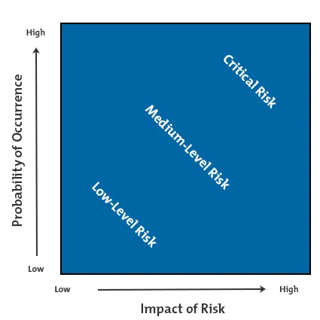
What risks have you identified that might affect your farm business? What will you do to manage them? Even though you are managing risks, what will you do when problems arise? Will you have back up plans for risks you haven’t planned for?
There are 2 things to consider when assessing risk:
- The likelihood of it happening to your farm (low or high likelihood)
- The impact it would have if it did happen to your farm (low or high impact)
For example, a tornado may have a high impact on your farm, but a low likelihood of happening. The risks to pay the most attention to would be those that would have a high impact on your farm business, and a high likelihood of happening.

